23/07/2021

Leo Comte

P2024

Volunteer experience

Lisbon Food Bank

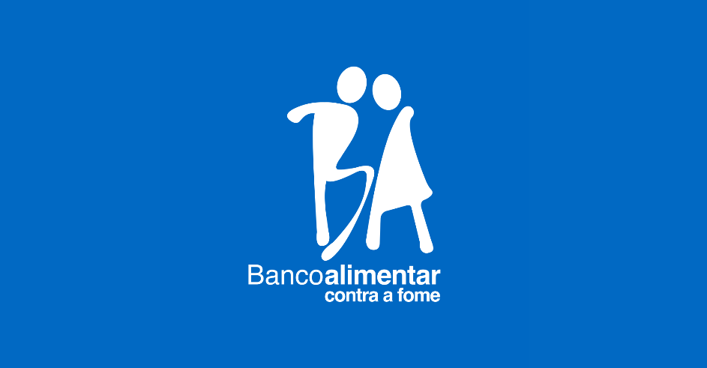

Table of Contents

Presentation of the NGO 2

Work done 3

Notion of citizen commitment 4

Conclusion 5

Presentation of the NGO

« Banco Alimentar contra a Fome (Food against the hunger » is a portuguese NGO located in Lisbon.

Banco Alimentar is a Portuguese group of twenty-one food banks. In this internship report, we are going to focus on the Lisbon’s food bank.

The main goal of the Banco Alimentar is to retrieve food which is going to be wasted and give it to people in need. All this represents several steps.

The first one is to retrieve the food. In 2019, the Lisbon Bank food gathered more than 7000 tones of food. It comes from the supermarket (44,2%), the farmers (9,3%), the MARL which is like Rungis in Paris (27,6%) and from donation campaigns (15,8%). One can see that 84% of the food collected is food which can’t be sold anymore because of the deadline, a surplus of production, vegetable which are too ugly or a false labelling. In this way, the food bank reduces the food waste.

The second step is to stock and spread the food. The Banco Alimentar have many warehouses where they stock the fresh and the non-perishable food.

Fresh food warehouse Vegetables in different conditions

Banco Alimentar doesn’t give food directly to people. They give the food to different NGO which shared it to people in need. Theses NGO can directly give the food or prepare some meal. To give some key figures, the banco Alimentar is linked with 375 institutions in Lisbon and its suburbs and every day, 75 of them come take food in the Banco Alimentar.

This operating mode allows to retrieve more food and then share it with more people. In 2019, the Banco Alimentar supported 66 thousand of people giving more than 12 million of meals. One may be reminded that there around three millions of people living in Lisbon and its area. One can observe that there are still a lot of people helped by the food bank in Lisbon.

All of this require a lot of labour. But the food bank works quite only thanks to volunteers. Only few people are paid to work there every day.

So, the Banco Alimentar lives thank to volunteers and donations. It does great collect twice a year to raise money and collect some food. Also, it launches campaigns to sensitize students. I could work with people from different social backgrounds: teenagers, students, unemployed people and even retirees.

60 tonnes of food in movement every day

12 millions of meals in 2019

375 institutions in link





66 212 people helped

75 institutions served every days

# 

# Work done

This second part relates my experience and what I did in the food bank. During one month, I made some different task and each one was very important for the food bank’s proper functioning.

The first task was to prepare the fresh food orders of each NGO. The fresh food included some fruits and vegetables, some dairy products, cakes and meat. To prepare the orders, we had lists on which foods and the quantities were specified. So, we had to take the food we need and put it on pallets. When it was done, we had checked all the products we have brought, and we report the missing products. Then we signed and we took another list.

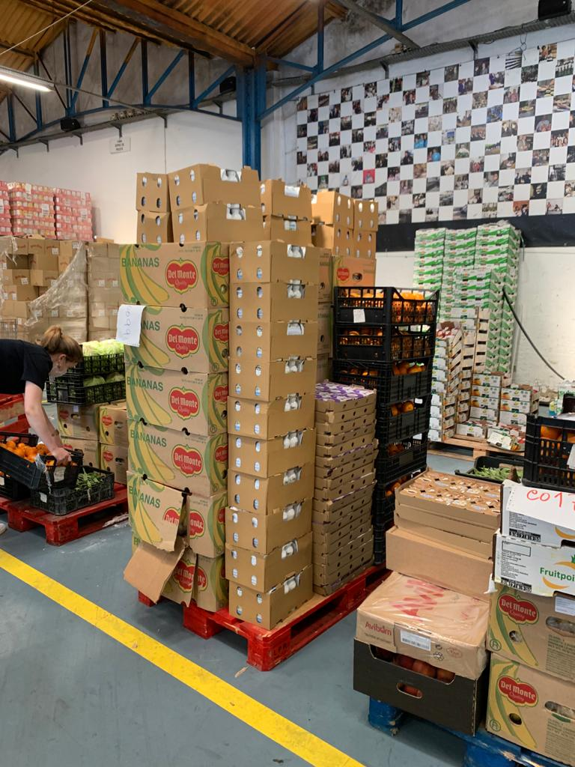 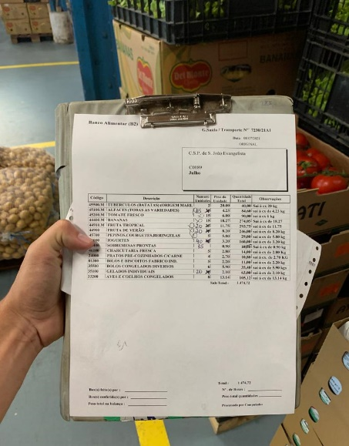

Fresh food command Command list

The commands’ size was constantly changing. The smallest were around 100kg and the biggest were around one tonne and a half. According to the experience in the Banco Alimentar, we could do command more or less important. On my side, I started with the smallest command. Then I made some progress and at the end of my internship I did only the largest command. I was quite proud of myself with this improvement.

The second task looks like the first one but instead of fresh food we had to pick non-perishable food. It includes some rice, paste, oil, cereale or even hygienic products like toothbrush.

Like the first tasks, we had a list on which there were all the food we should put in a box. A box is a pallet on which we put a steel grid. For this task we didn’t have the quantities but only the weight. For example, instead of 50 bottle of oil we had 60kg. So, we had to weigh everything. To this end we had a pallet scale. When we were a lot of volunteers and the pallet scale was not available, we could use also a big scale not included in the pallet but it’s was a bit longer.

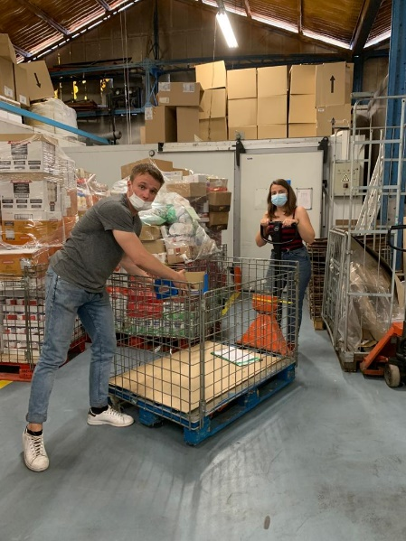 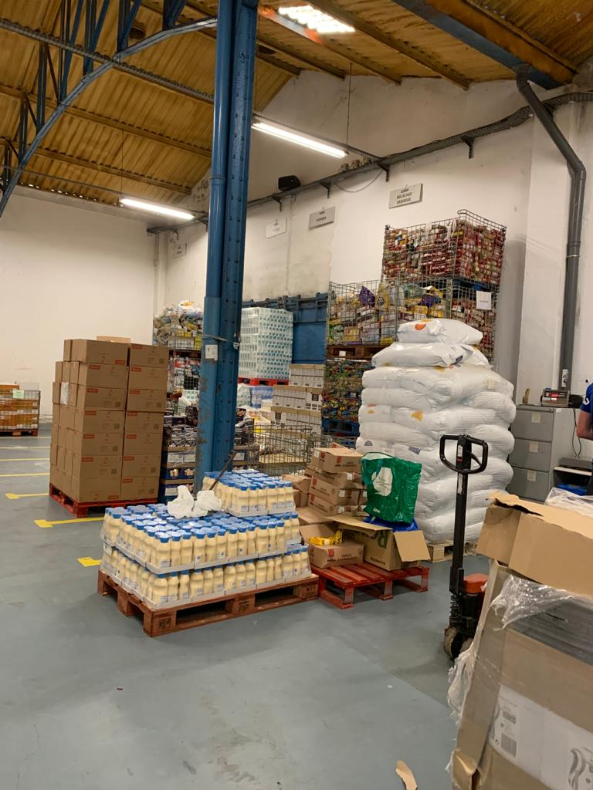

Box on a pallet scale Non-perishable stock

The non-perishable food can stay in the warehouse for a long period of time. Therefore, there are less command but there are bigger. They were between 500kg and two tones. And as we didn’t know the number of products but only the weigh, this command took much more time. As an example, we could make around 30 fresh food’s commands but only three commands of non-perishable food during the afternoon.

The third task is simpler than the others. Indeed, it’s about sort and store the stock. Indeed, the Food Bank received a lot of food and sometimes it comes untidy. In this case we have to put it in boxes to facilitate the storage. Of course, we do that only with the non-perishable because the fresh food dones’t stay more than one or two days in the warehouses.

This task is very useful when the Banco Alimentar does food collects. Indeed, they are composed of a lot of different bulk products.

Now I am going to present you a ordinary day in the food bank. The days there were really organised.

The day begin at 9 and a half and it was always the same. A leader presents us the fresh products of the day. Then we started to prepare the orders. The morning is split into two parts. During the first one we prepare the orders which are being taken in the morning. When all the orders were made, we had a break. The other NGO come to take their command. When it’s done, we can do the second part. During this one we prepare command which are being taken in the afternoon. So, we don’t put the frozen food on the pallet (the frozen food is considered as the fresh food). When it’s done, the morning part is finished. This part was the most tiring because we had to be fast and to carry heavy products. It was done quite only by volunteers. The number of volunteers changed every day.

Then we had two hours break. It allows to meet the other volunteers.

During the afternoon we can make different activities. Most of the time I prepare the non-perishable commands. If there were no food, we could finish the « afternoon’s order ». That’s mean putting the frozen food on it. Indeed, we don’t put the frozen food during the morning to not let it too much time outside of the freezers. When it’s done, I can store the food. There is always something to do in the Banco Alimentar.

# Notion of citizen commitment

One can define the civic commitment as a participation in the society life and a contribution for the common good. The civic commitment internship is at first a social experience which tend to understand and stand against society issues as the inequalities, environment issues or the poverty.

My internship allows me to realize that even in our rich countries, there are still a lot of people who need food. In addition to this, there is also a lot of food which is wasted. Even if I was aware of it, seeing that during one month, it’s immediately more concrete.

Nevertheless, I was pleasantly surprised when I saw all the volunteer, young or old, who were really involved to help people in need.

The food bank has two main goals; reducing food waste by collecting food which was supposed to be thrown away. Then giving it to people who are hungry. The first one is ecologic and the second one is social.

When I worked in the Food Bank, I did a lot of things which helped to redistribute the food. I gave my time to be useful for other people and so for the society. Therefore, one can qualify my internship as a civic commitment.



# Conclusion

To conclude, the Banco Alimentar is an important NGO which help thousands of people thanks to a perfect organization. During my internship, I was quite impressed by the fact that there was quite no loss. Nevertheless, it doesn’t work without all its volunteers. Indeed, thank to this internship, I realize that everyone can be useful for the society, just giving some time and good faith. Each participation, even if it does not seem a lot, matters.

I might regret not to have meet people I helped. However, the meetings I did in the food bank were also really rewarding. I worked with people who come from all backgrounds and all ages, from 14 to 80 years old. I realized that the age doesn’t matter. If you want to help people you can be young or old, we don’t mind! The will is the only thing that matters.

Finally, it was a great experience and I’m sure I would do volunteering again in my life!